What to improve for Spectra (Malaysia Loan & Finance Calculator)
Okay starting with Home page,
on the sticky row, we can add in the spectrality’s word logo, make the word logo colourful, and the burger button colour too. And a distinction colour or line between page and sticky bar.
For the title of “loan planner” change to “Smart Financing” , with description changed to “What wise financial decision should we make today?”
For the word “today snapshot”, we should change it to “Personal Finance”

Then move the buttons for loans up to underneath the descriptions.
make 2 (column) x3 (rows) button

Next for dashboard:
Under page inventory, inventory details, could we make all headers filterable and can sort by ascending, descending etc.? same with orders table under sales.

After that, let’s start building amazon ads
for amazon ads part since we will build a new page for it, this is mainly for P&L so we only need to combine all invoices together the cost and breakdown taxed amount.
I would also like to have an analysis breakdown of the ads I ran to see how much ads I spent on each SKU, split data by weekly, month and overall. I will share you the amazon extracted advertise products template for you to refer what I will upload to you monthly or whenever. If there’s duplicated can remove, these will be arranged by dates and skus as main.

Then I wan to have a simple dashboard of sales generated from ads and amount spent and also sales that were not capture by ads. Do have the metrics listed down in table and have them with filter, functions, ascending decesding and filter too.

For Storage cost and inventory aged surcharge, goodcang’s api code can be taken from here 获取仓租明细, 获取费用流水, 获取充值明细

Currently all storage cost are calculated by CBM per day, not sure if you are able to extract the latest uk data from goodcang’s backdoor, as they have their own way of calculation, the price I have changes via reporting but I was wondering if there’s direct api where you can just extract and do so instead of us manually key in
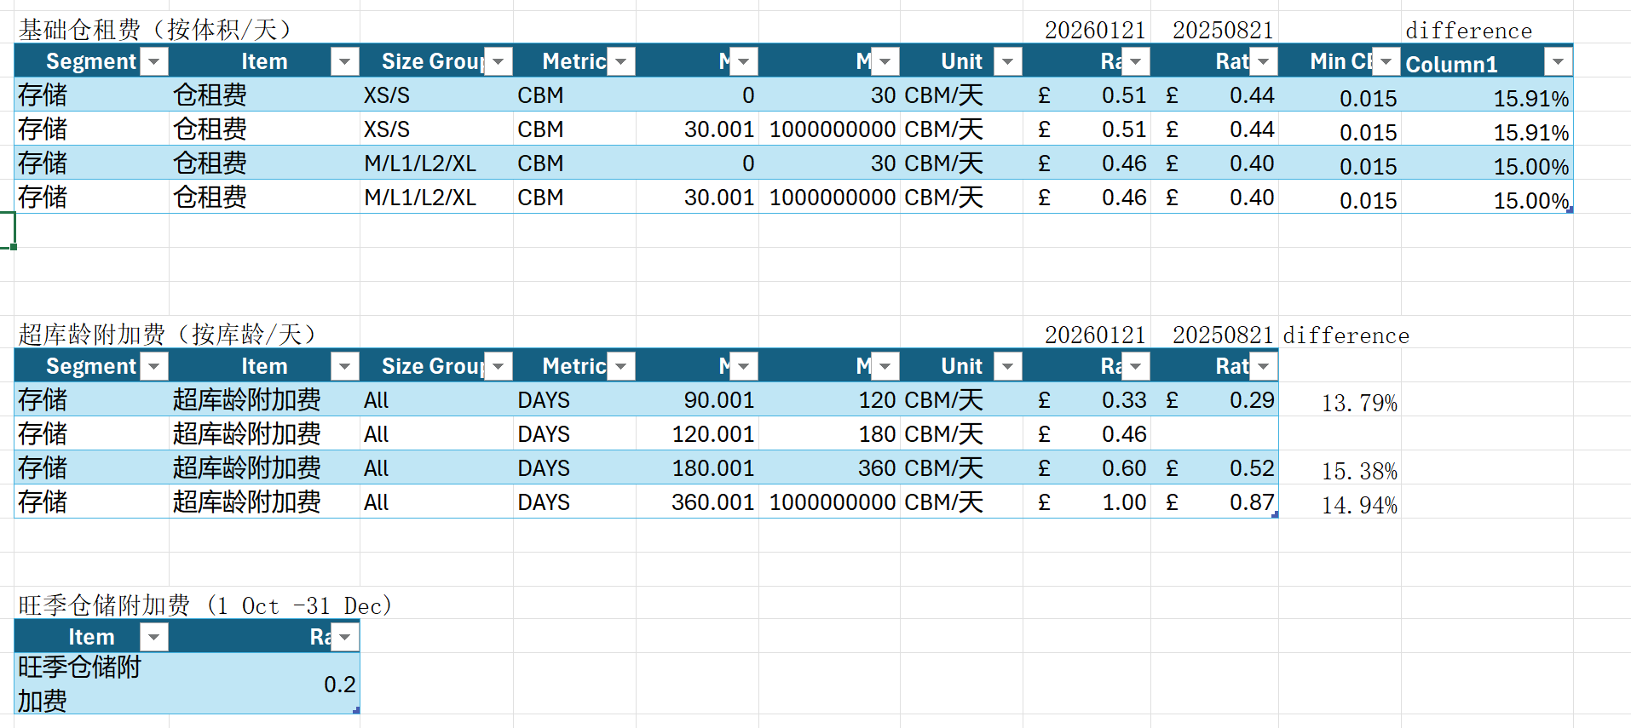

 |  |  |  |  | 20260121 | 20250821
环节 | 费用项 | 费用段 | 库龄段 | 计费单位 | 英国  GBP | 英国  GBP
存储  （最小计费体积详见【规则说明】） | 仓租费 | XS  S | 0<X≤30 | CBM/天 | 0.51 | 0.44
 |  |  | X＞30 | CBM/天 | 0.51 | 0.44
 |  | M  L1  L2  XL | 0<X≤30 | CBM/天 | 0.46 | 0.40
 |  |  | X＞30 | CBM/天 | 0.46 | 0.40
 | 仓储费  (客户物流) | XS  S | 0<X≤30 | CBM/天 | 0.51 | 0.44
 |  |  | X＞30 | CBM/天 | 0.51 | 0.44
 |  | M  L1  L2  XL | 0<X≤30 | CBM/天 | 0.46 | 0.40
 |  |  | X＞30 | CBM/天 | 0.46 | 0.40
 | 超库龄附加费  （x代表库龄) | 90<X≤120 |  | CBM/天 | 0.33 | 0.29
 |  | 120<X≤180 |  | CBM/天 | 0.46 | 0.52
 |  | 180<X≤360 |  | CBM/天 | 0.60 | 0.87
 |  | X＞360 |  | CBM/天 | 1.00 | 0.21
 | 超尺寸仓储附加费 | All |  | CBM/天 | 0.24 | 0.20
 | 旺季仓储附加费 | All |  | CBM/天 | 0.20 | 4.44
附加服务 | 商品尺寸重量复核 | All |  | 件 | 4.44 | 0.09
 | 商品库存数量盘点 | All |  | 件 | 0.09 | 0.98
 | 商品拆分  商品合并  商品转换 | All |  | 件 | 0.98 | 0.98
 | 贴标费 | All |  | 件 | 0.98 | 4.89
 | 拍照 | All |  | 件 | 4.89 | 2.93
 | 商品辨识核实  (不拆外包装直观辨识) | All |  | 件 | 2.93 | 4.89
 | 商品辨识核实  (拆外包装辨识) | All |  | 件 | 4.89 | 1.39
 | 新品查验费 | XS/S/M |  | SKU种类 | 1.39 | 2.31
 |  | L1/L2 |  | SKU种类 | 2.31 | 3.38
 |  | XL |  | SKU种类 | 3.38 | 1.20
 | 商品重新包装 | All |  | 件 | 1.20 | 双倍操作费
 | 库内订单拦截 | All |  | 订单 | 双倍操作费 | 不限
 | 其他特殊增值服务 | All |  | / | 不限

